P:\HPS\Honeywell Templates\graphics\Output\!!Database_Files

Select “Geneology for ID” and “Search”

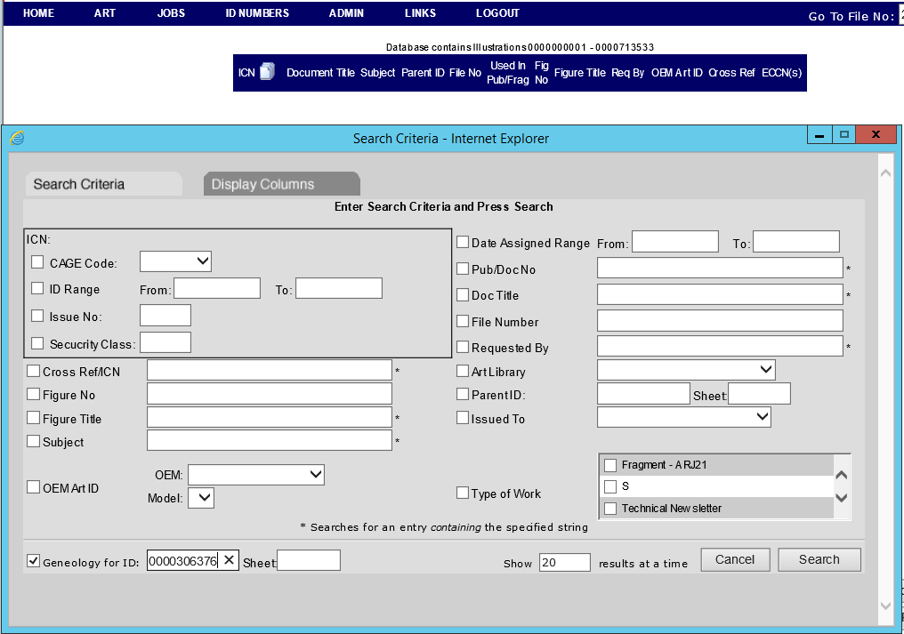

Select “My ID No List” and CLEAR THE LIST.

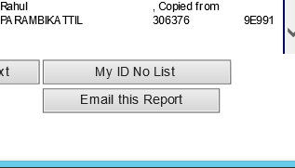

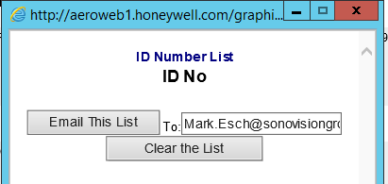

Select “Add all to my ID list”.

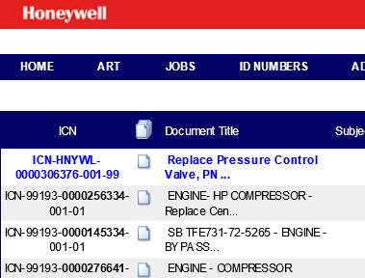

Select “My ID No List”.



Select “Email This List”.

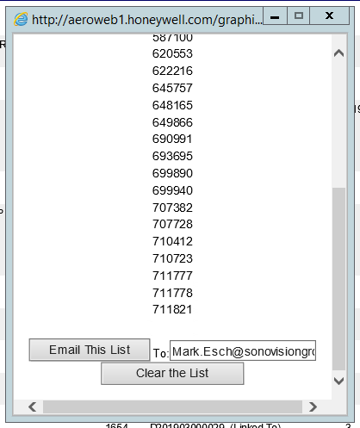

Copy file to P:\HPS\Honeywell Templates\graphics\Output\!!Database_Files

Name file Replace_With_0000XXXXXXX.txt